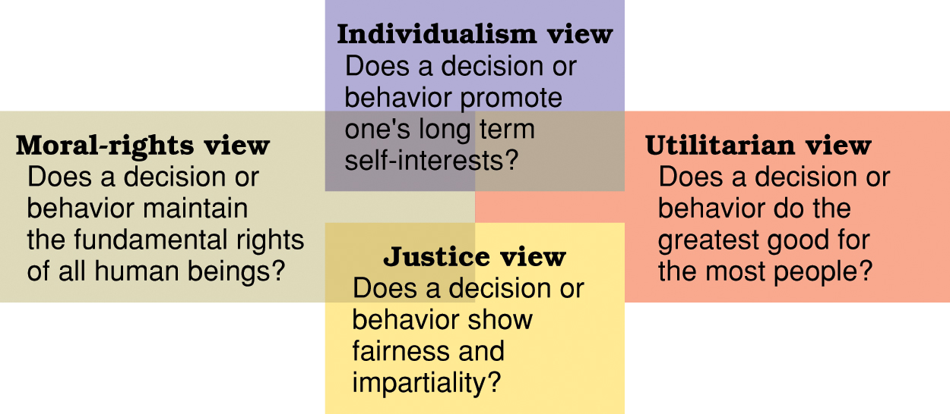Four Views of Ethical Behaviour
Utilitarian view – Cut 30% of a plant’s workforce in order to keep the plant profitable and save remaining jobs
Individualism view – Overlook other’s potentials to get yourself to the top
Moral-rights view – Employees are always protected in terms of rights to privacy, free speech, health and safety, etc.
Justice View – 1- policies and rules 2- treated the same regardless of race, gender, age, etc. 3- treat with respect

