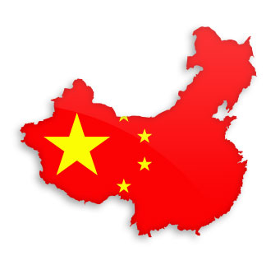
Death by China
- What does mass production of goods in China mean for North America?
- What are the ‘Weapons of job destruction’?
- What are the ‘bad’ reasons for being a good producer?
- What is currency manipulation?
- Do you think about where the products you buy are made? Why or why not?
- Do you think products made in China could be a danger to your health? Why?
- If you were the CEO of a large company, like Apple or Intel, would you keep the production locally or would you move it to China? Why?

