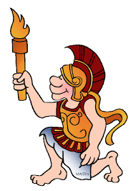
Ancient Greek Olympics Reenactment
Divide into small groups of three to four.
Using available resources, each group’s task is to research and then re-enact a plausible and classroom-appropriate scene from the first Olympic Games.
Possible events as suggested by the articles we read, you will be assigned any of the following scenes:
- an athlete warming up for his event with weights and olive oil while confiding in another athlete about his exercise routine
- an engineer describing physical and structural attributes of a stadium to another engineer
- a Games official checking starting points and explaining about the usage of equipment for various events
- a stenographer or vase painter chronicling the events of the day.
~ Your group should be particular to focus on the athletes in their scenes, such as what physical and social attributes would the athlete portray?
~ Groups should first script their general idea on paper, research at least ten historical facts to supplement the validity of their scene, and then assign and practice roles while obtaining or creating props, if necessary.
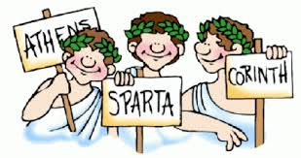
~ After groups are finished, you will have time to present your scenes to your peers.

