Battle of the smartwatches: How the Apple Watch compares to its competition
By Nicole BogartTech Reporter Global News
TORONTO – 2015 is turning out to be the year of the smartwatch. Despite slow consumer adoption, nearly all major tech players have released new smartwatches over the last three months.
Now that there is an official release date for one of the most anticipated devices –the Apple Watch – we decided to compare some of the newest smartwatches on the market to see how they stack up.
Below we explore some of the features of the Apple Watch, Moto 360, Samsung Gear S and the Pebble Time to see how they compare.
However, keep in mind that each device is quite different and comparing all of the technical details of each device isn’t the most accurate way to choose which smartwatch is right for you. For example, the Apple Watch is only a viable option to iPhone users – just like Moto 360 and Samsung Gear S are reserved for those with Android devices.
Here’s a look at how some of the technical details of these devices compare. Below, we also have a rundown on how each device differs in terms of customization and style.
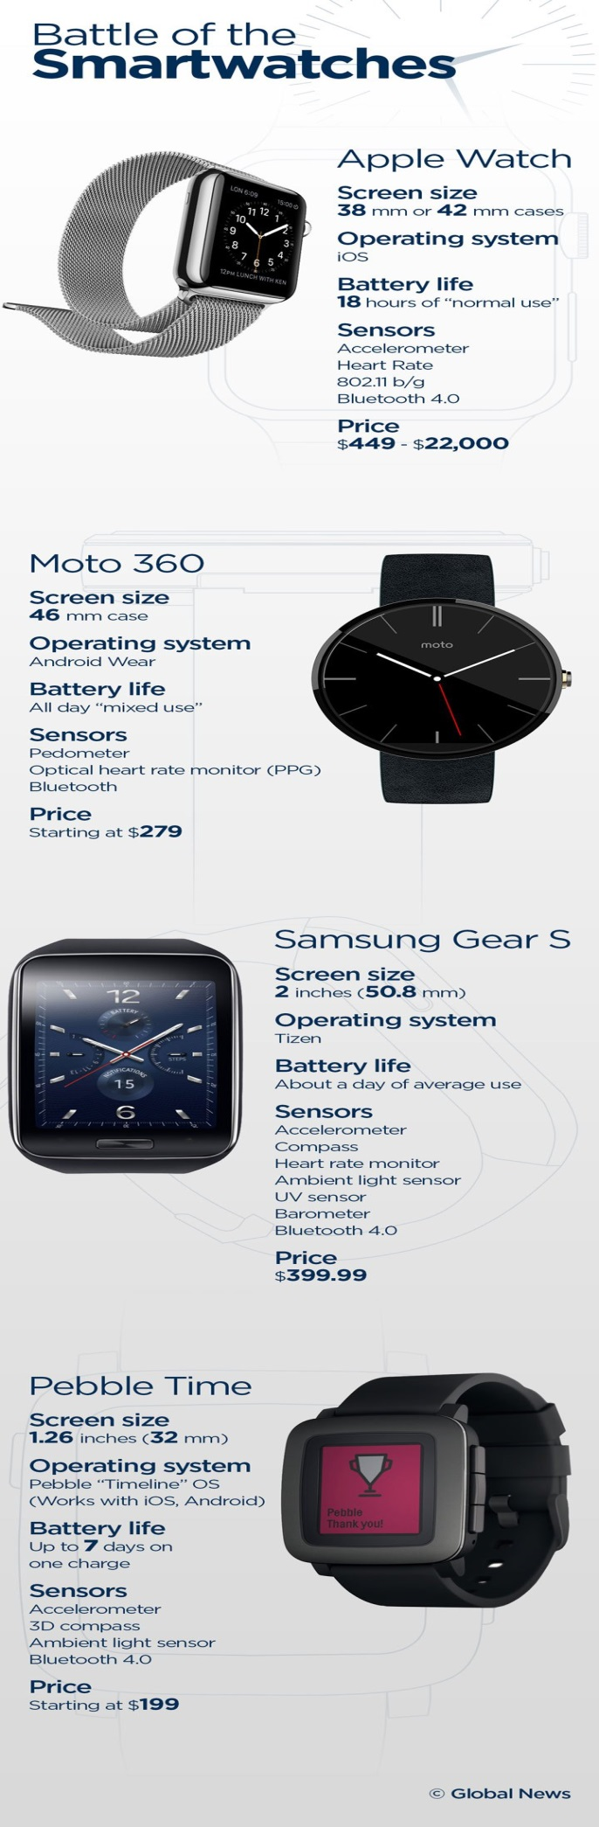
The one thing these smartwatches do have in common is style – each one offers a different take on making a smartwatch fashionable.
For example, to compete with Apple’s customizable watch design Motorola launched a customization option for its Moto 360 smartwatch.
Moto 360 has already been celebrated for its sleek traditional circular watch face,but now users can choose different colored watch cases, wristbands (leather and metal) and watch faces. Each customization costs about $30 to $50.
The customization option is only available to U.S. residents at the moment and it’s unclear when it will be available to Canadian consumers. Right now the device is available in black, stone, black metal and champagne metal at Canadian retailers.
Similarly, after launching a Kickstarter campaign for its Pebble Time smartwatch,Pebble unveiled Pebble Time Steel – an upgraded version of the device aimed at those looking for a fancier finish. The Steel version has the same tech specs as the Pebble Time, but comes in silver, black and gold finishes and costs $100 more than the original version.
The Apple Watch has the most options for customization – with over 22 possible combinations – but each comes with a wildly different price tag, from $449 to as much as $13,000 for the gold Edition model.
It’s also worth noting that the Samsung Gear S smartwatch is in a league of its own when it comes to connectivity.
It has built in 3G technology, which means it doesn’t have to be wirelessly connected to a nearby smartphone to receive emails or notifications. It’s also been criticized for being the most unattractive of the smartwatches on our list, thanks to its large two inch display and sporty design.
Questions:
- Who do you think has the competitive advantage for the smart watch?
- When a company is ‘racing’ to launch a product, how do you think this could affect the quality control of the product?
- Would this be a product that you would buy and wear? If so, why and which one would you buy?

