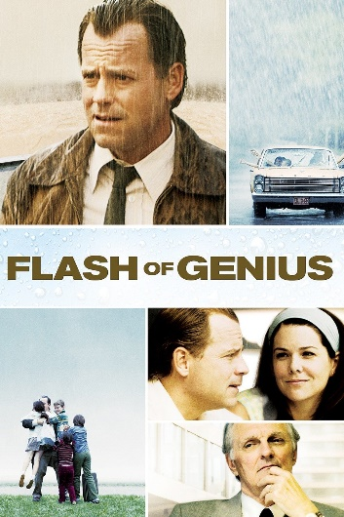
Flash of Genius Movie Questions:

- What is a ‘Flash of Genius’?
- What entrepreneurial characteristics does Robert possess?
- Do you think Robert is too obsessed about his innovation? Why or why not?
- What are the positive results for Robert as an entrepreneur?
- What are the negative results for Robert as an entrepreneur?
- What is the difference between an invention and an innovation?

