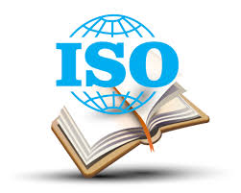
ISO Standards Web Search Activity
BBB4M
http://www.iso.org/iso/home.htm
Utilizing the above web link, answer the following questions.
- Why are standards important?
- What is ISO?
- Is ISO a government organization? How many countries are included in the ISO network.
- When did International standardization start?
- ISO benefits society in 7 ways. List them.
- Is ISO voluntary or mandatory? What are the implications of this.
- What is the connection between the ISO and the WTO (World Trade Organization)?
- What are generic management system standards?
- What is the difference between ISO 9001 and ISO 14001?
- Investigate the following Companies based in Canada and find out if the company is ISO certified. If so, which certification is it?
  - Honda Canada
  - Bombardier
  - Essar Steel Algoma

