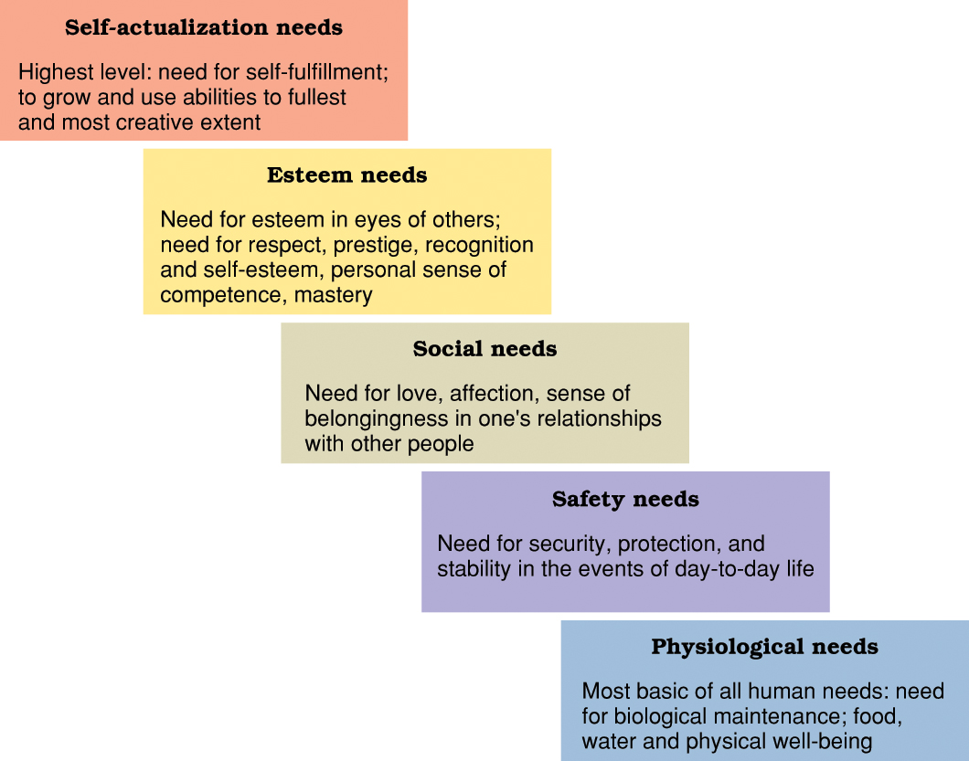MASLOW’S HIERARCHY OF NEEDS

