International Marketing
Product Development Activity

Scenario: You are the new Marketing Manager(s) for Frito Lay Canada and have been appointed to find a new Market for an exciting new flavour of potato chip.
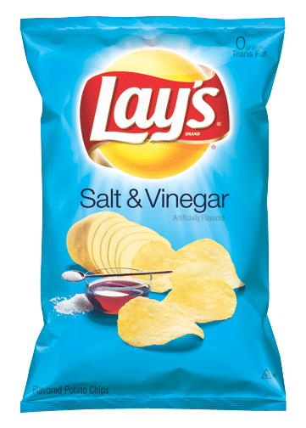
To Do:
Post your marketing decisions about your chips:
- Name
- Flavour
- Country
- Image (can be a picture, advertisement, and/or logo)
- Brief explanation of why it will appeal to your market

Post as a comment at http://www.brincatblog.weebly.com
Class will vote on best Chip

