Integrating Beavertails into Japanese Society
A report for foreign investors

Kayla Nowlan
Mr. Allen
3 June 2014
Table of Contents

Introduction and Rationale….……………………………………………………………............3
Japan Fact Sheet………………………………………………………………………………….4
Political Profile………………………………………………………………………………….10
Company and Product…………………………………………………………………………..16
Japanese Culture Fact Sheet……………………………………………………………………18
International Marketing Plan……………………………………………………………………20
Recommendations and Conclusions……………………………………………………………22
Works Cited……………………………………………………………………………………..23

Introduction and Rationale
Integrating any domestic product into a foreign culture can be challenging. The purpose of this report is to provide foreign investors with the knowledge they need to export BeaverTails Pastry’s beavertail into Japan.

If the integration is smooth, beavertails should be a great success in Japan, particularly in the Harajuku district in Tokyo. The reasons for this will be detailed as we explore Japan in this report. In this report, the reader can expect to find facts and statistics detailing the geographic, the demographic, and the economic sides of Japan. Political issues as well as human rights issues and legal issues will also be focused on. This information is important for investors, especially since this will let one know how stable the country is. Details about the success of BeaverTails Pastry in Canada and a plan on how to import this success into Japan will also be talked about near the end. Hopefully, this report will arm foreign investors with the knowledge they need to make executive decisions regarding the globalization of beavertails.

JAPAN FACT SHEET
The following fact sheet is organised into three sections:
Geographic, demographic, and economic.
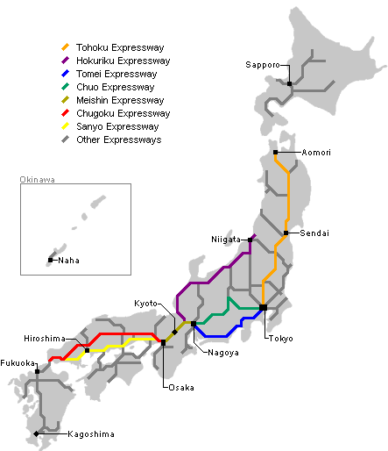
Major Highways (Japan Guide)
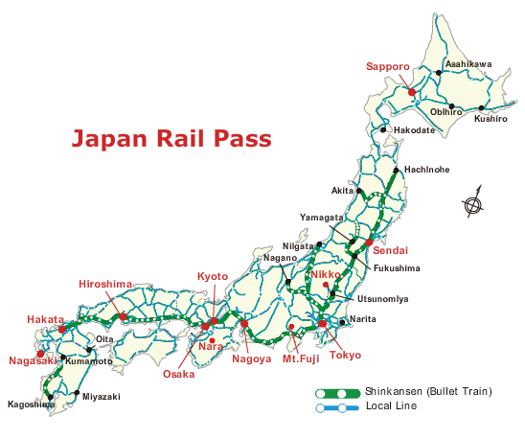
Major Rail Lines (Japan Travel)
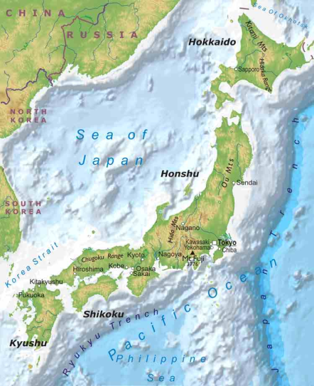
Physical Characteristics of Japan (Free)

GEOGRAPHIC
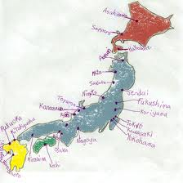
Major Cities (Think)
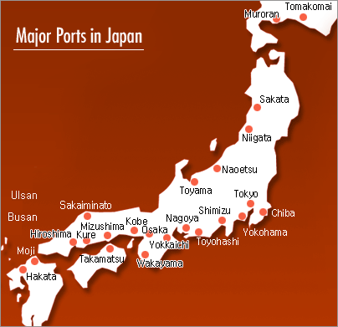
Major Ports (Japan Auto)
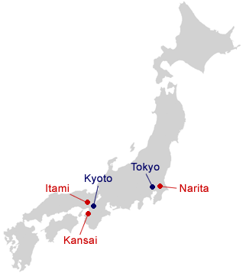
Major Airports (Cosmos)
Country Name: Nihon, Nippon
(Pronunciation depends on how speaker wishes to pronounce the kanji characters, 日本)
The combination of these two characters means: “origin of the sun” or “land of the rising sun.”
There are no conventional long form/short form names of Japan (Nation)
Japan is roughly 26.42% of the area of Canada.
Area of Japan: 377 944 km²
Area of Canada: 9 984 670 km²

(Total)
DEMOGRAPHIC
Japanese is Japan’s official language. Japan has several dialects though, such as the Tokyo dialect and the Kansai dialect. With regards to language however, there are couple non-Japanese languages spoken in Japan. Below is a list: (Ethnologue)
Ainu: 15 000
Amashi-Oshima Northern: 10 000
Amashi-Oshima Southern: 1 800
Japanese: 121 000 000
Japanese Sign Language: 317 000
Kikai: 13 100
Korean: 670 000
Kunigami: 5 000
Miyako: 67 700
Oki-No Erabu: 3 200
Okinawan Central: 984 000
Toku No Shima: 5 100
Yaeyama: 47 600
Yonaguni: 800
Yoron: 950

The above numbers where not recorded as percentages due to the fact that there are people who can speak more than one of these languages, which will cause the percentages to become unbalanced.
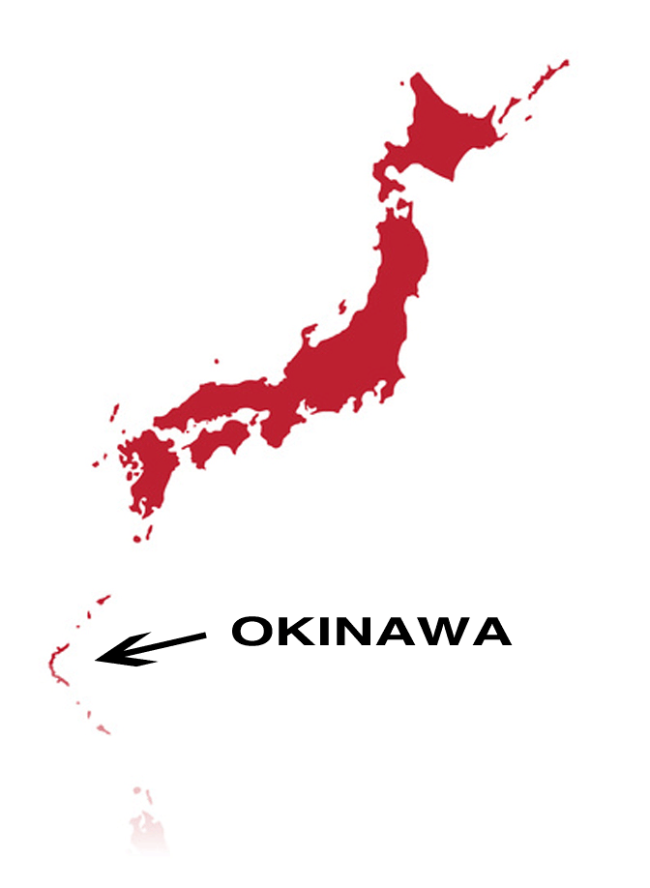
Except for Okinawa, the rest of Japan gets four distinct seasons. Like our neighbours to the south, their summers are hot and brutally humid. This heat lingers in the fall, and then finally drops in the winter. Okinawa gets a Hawaiian-like climate. (Rak)

Japan is a mountainous country. Because of these mountains, about 80% of the population is crammed into about 20% of the land, between the valleys. Due to cramped conditions, a rule called meiwaku is extremely important to the Japanese and essential to their culture. It is the opposite of Golden Rule: “Do unto others as you would not want unto you” This can include things like playing your music too loud. Japan has hundreds of islands, but much of the population chooses to inhabit one of these four: (Rak)

Honshu. Means “main state.” Largest and central of the four, with about 100 million people. Home to Tokyo, Osaka, Kyoto, Nagoya, Hiroshima)

Hokkaido: Famous for annual ice festivals. It is north of Honshu. Name of island literally means “north sea route.” Not as mountainous. Much of dairy production takes place here.

Kyushu: Means “9 states,” contains 9 prefectures. One of its largest cities is Fukuokua (1.4 million people, international airport)

Shikoku: means “four countries.” Contains 4 prefectures. Smallest and least populous, with around (4.5 million people)

Okinawa: located far to the south, about midway between Taiwan and Japan. Originally a separate, independent nation called Ryukyu Kingdom. Forcibly made part of Japan in 1879 so many residents consider themselves Okinawans first, Japanese second. (Rak)

Time Zone: UTC+09:00
When it is noon in Ottawa, it is 2:00 pm in Japan of the next day (there is a 14 hour difference)

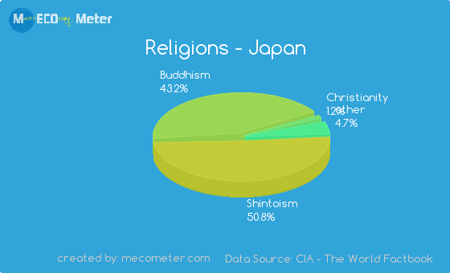
Literacy Rate: 99% (CIA)
Urban to Rural population (%): 66.8 : 33.2 (Trading)

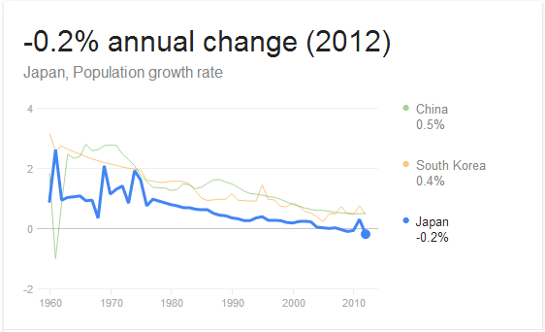
Figure 7 Religious Groups (Mecometer)
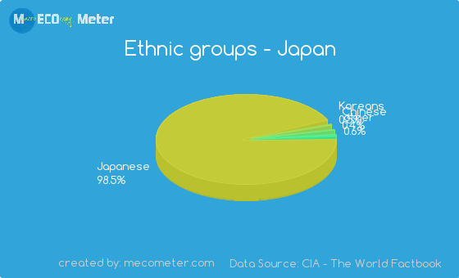
Although Japan is severely smaller than Canada in terms of land mass, Japan has a much higher population. The entire population of Canada makes up only 27.8% of Japan’s population. As of March 2013, their population is 126, 393 679. (Japan Times)
Figure 8 Ethnic Groups (Mecometer)
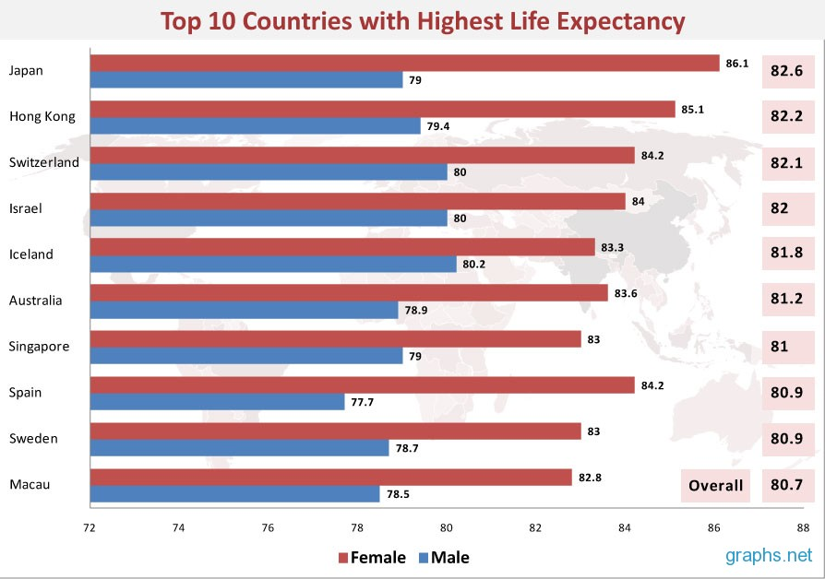(World)

(Trading)
(Index)
ECONOMIC
GDP: 46,720.36 USD (2012) (World Bank)
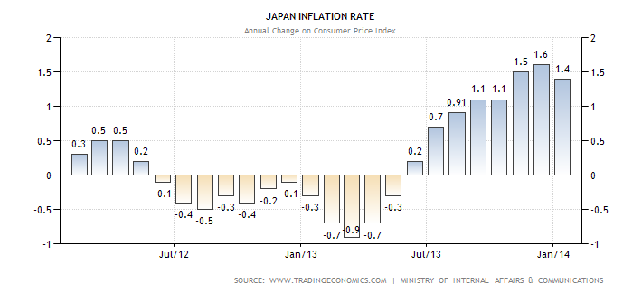
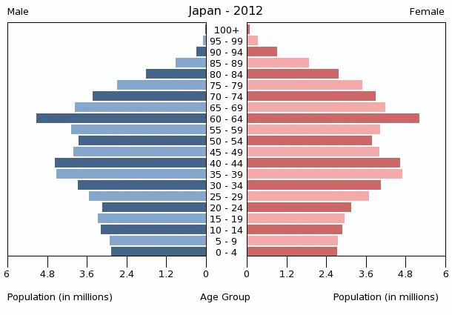
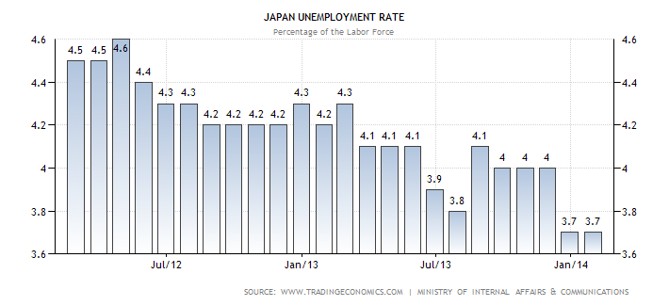(Trading)
Currency: Yen
1 Japanese yen equals 0.011 Canadian dollars; One Canadian dollar is 92.67 yen.

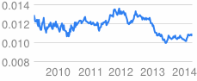
Figure 9 Currency Stability to CAD
Top Export Partners | Top Import Partners
P.R. China | Russia, USA
Germany, Ireland | Germany
Bahamas | Philippines
(Jetro)

Industry | GDP value-added $ billions 2012 | % of total GDP
Other service activities | 1,238 | 23.5%
Manufacturing | 947 | 18.0%
Real Estate | 697 | 13.2%
Wholesale and retail trade | 660 | 12.5%
Transport and communication | 358 | 6.8%
Public administration | 329 | 6.2%
Construction | 327 | 6.2%
Finance and insurance | 306 | 5.8%
Electricity, gas and water supply | 179 | 3.4%
Government service activities | 41 | 0.7%
Mining | 3 | 0.05%
Total | 5,268 | 100%
(Prefecture)

Political Profile
The political climate of a country is an important factor businesses must consider before they actually do business within a given country. The next following pages will give a general outline of Japan’s political profile with respect to the government, political issues, and legal issues.
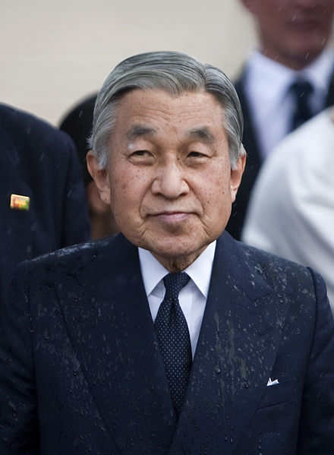
GOVERNMENT
Much like England, Japan is a parliamentary democracy that runs under a constitutional monarch. Although Emperor Hirohito was forced to give up his divine status after World War II, his son—who succeeded him in 1990 after his death—Emperor Akihito continues to sit on the Chrysanthemum Throne and serves as a symbol of unity for the Japanese (About). The emperor may be the chief of state, but the head of the government is the prime minister, the leader of the majority part of the Diet. The Diet is made up of two houses, the House of Representatives and the House of Councillors. Both of these houses are elected, although the house with the most authority is the House of Representatives. (Morrison)
The current Prime Minister is Shinzo Abe, who was elected from the Liberal Democratic Party in December 2012. He was the youngest Prime Minister to ever get elected after WWII in 2006, but had to resign in 2007 due to health issues (Washington). Japan’s next national election is expected to take place on 16 December 2016, but of course the election could also be called earlier (Wikipedia 47). This, however, does not seem likely due to the fact that the opposing party has very little seats. The World Politics Review comments: “If there was ever a threat to Japanese Prime Minister Shinzo Abe’s leadership in recent months, it was annihilated last weekend. Not a single candidate from Abe’s ruling Liberal Democratic Party (LDP) lost in the latest Tokyo municipal government elections, while the biggest national opposition party even fell behind the communists.” (World Politics)
For Canada, Japan’s view on international trade is a healthy one. In 1945, and Japan was in ruins from the aftermath of the second world war, the country decided to adopt a policy of modernization. With help from North America, demolished industries and factories were rebuilt with much higher standards. The Japanese culture also vigorously promoted high-quality education and a strong work ethic. Schultz notes that Japan “aggressively pursued international trade options.” In the beginning, Japan’s products could be compared to the “made in China” label, but many Japanese companies tried to turn this image around, such as Nikon and Canon. In the end, it was Sony (originally called Totsuko Company, but changed their name for ease of pronunciation in international markets) and its pocket radio that redesigned Japan’s image. Today, Japan is seen as a country with high quality products and reliable business practices, and an excellent trade partner. (International)
Of course, there are also tariffs associated with doing business in Japan. There are hundreds of tariffs with regards to foreign competition in Japan. The following table represents only a small portion of the tariffs placed on plastic goods. alone
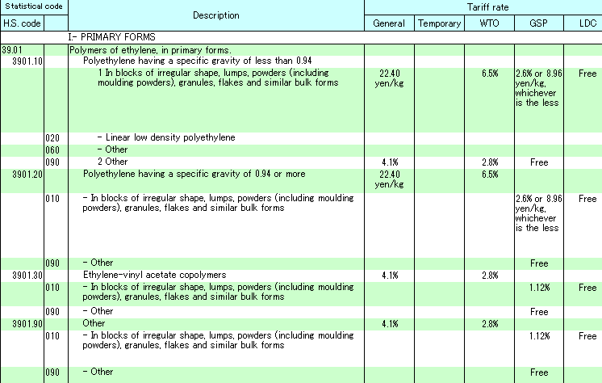
(Japan Customs)

POLITICAL ISSUES

Ever since the Abe government has been elected, there has been greater political stability in Japan. As mentioned in the preceding subsection, “Not a single candidate from Abe’s ruling Liberal Democratic Party (LDP) lost in the latest Tokyo municipal government elections.” With little to no opposition, the government will be able to make decisions a lot faster and with great ease. At the same time, however, the World Political Review further comments: “Though Abe’s political dominance could bring an end to Japan’s stretch of political instability…the lack of any meaningful opposition to the LDP can only bode ill for the country’s long-term prospects.” (World Politics)

Although currently, Japan may be experiencing some political stability, this sudden rush of power to the LDP has actually caused Japan’s ranking for female quality to drop four places in 2012. The Global Gender Gap Report ranks women’s equality in 136 countries and focuses on four areas: politics, economics, health, and education. Experts believe this sudden drop is partly due to the national election from the Lower House in December. The ratio of female politicians dropped from 11 percent to eight percent. According to the report, women also represent only ten percent of company executives in Japan. The report mentions that “Japan is failing to have women more involved in society despite their achieving a higher education level.” (Asahi) Hopefully, Japan will work hard to improve their standing in the Global Gender Gap Report in the years to come.

Another political issue frequently brought to the attention of foreign investors is corruption. Compared to other places, such as certain countries in Africa, China, and a couple other countries in Europe, Japan is not very corrupt. According to the map below, Japan’s “corruptibility” can be compared to the United States.

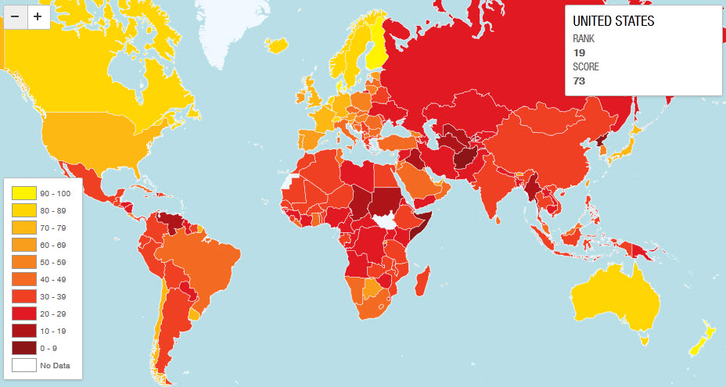
(Zero)

Even so, according to the Business Anti-Corruption Portal, “Japan does not sufficiently enforce the OECD (Organization for Economic Co-operation and Development) Anti-Bribery Convention, which they are party to.” This will be discussed again in the next subsection. The portal also comments on whistle blowing in Japan. Although there is a legislation that protects whistle-blowers from recrimination, they are still at the high risk of being harassed, demoted, or even fired. (Business)
There is also the issue of “black companies” (ブラック企業) in Japan. Essentially, black companies are unethical companies operating in Japan. In 2012, journalists, activists, and university professors created the Black Company Awards, hoping to raise awareness of these unethical companies. Nominations are made based on the following categories:
- Actual public records on occupational problems such as a long work time, sexual harassment, or abuse of power.
- Long intense work hours.
- Low pay.
- Compliance violations.
- Flaws in the system, such as lack of childcare leave or maternity leave.
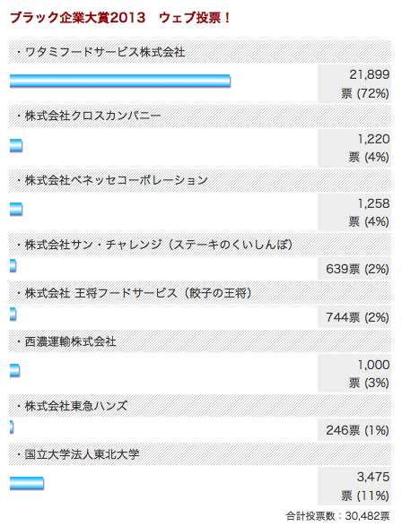
- Hostility to unions.
- Discrimination against temporary workers.
- Temporary worker dependance.
- Unpaid overtime (and lies about paid overtime in the job advertisements).
Watami FoodService Co, LTD (Restaurant Chain) has won two years in a row by a landslide (see figure to the right).
Mami, a writer at Tofugu (a blog on Japanese culture) mentions in her article:
“Watami’s winning streak is due to its notoriously abysmal mistreatment of young workers. In 2008, Mina Mori, a female employee of Watami, committed suicide at the age of 26 after reportedly working 141 hours of overtime in one month. It happened just two months after joining the restaurant chain. Some people may think committing suicide is an individual matter and that a company cannot be held responsible. However, it is reasonable to assume Mori would not have chosen suicide for herself had she not been forced into such a desperate situation. Furthermore, it is apparent just how “black” the Watami company is simply by the cold reaction of Watami founder Miki Watanabe’s reaction to the case. He not only refused to meet with her family but also refused to apologize to them until last month. He finally did offer an apology in court on March 27, 2014, though he still has denied liability.
According to an interview with a former Watami restaurant manager conducted by Takarajima magazine (September 2013 edition), upon hearing the news of Ms. Mori’s suicide, the ex-manager wondered if it was really just 141 hours. During his time at Watami, he regularly worked from 7am to 12am with almost no break, making his monthly overtime over 300 hours. He also revealed that Miki Watanabe gives extreme messages to workers on every payday, such as: “Regret as hard as you die!” He even received a personal letter from the evil president in his paycheck envelope saying: “you should reflect on your sales this month by killing yourself.” (Tofugu)
Another political issue that should be mentioned is the role of the Japanese “military.” Instead of a military, Japanese has a special self-defence force (SDF) to protect the mainland, due to the fact that Japan was forbidden to have a military after WWII. According to the Council on Foreign Relations, “Even with these limitations, the SDF has performed a paramilitary, logistical role, supporting US. Troops based in Japan in exchange for protection.” Over the last two decades, arguments for remilitarization have gained circulation. The country is one of the world’s largest spenders on national defense, though the SF includes no long-range bombers or missiles, no aircraft carries, or nuclear submarines. In recent times, Japan has come under accumulating pressure to expand its “military” operations (not only domestically, but also from the United States) due to threats from China and North Korea. (Council)
LEGAL ISSUES
As mentioned earlier, Japan is not actively enforcing the detection and investigations of bribery cases. Since Japan’s foreign bribery offence legislation made its entrance in 1999, the OECD has only concluded two cases. To strengthen the enforcement of this law, Japan is giving considerable consideration to using techniques such as wire-tapping and grants of immunity from prosecution. (OECD)
However, it should also be noted that perhaps the reason there have only been two cases is because bribery is not prevalent in Japanese society. A recent survey investigated the number of business people in different countries who think they’ve failed to win a contract or gain new business in the past 12 months because a competitor paid a bribe. According to Japan, only 2% of Japanese business men and women believe they have lost a contract due to bribery from the competition. (Transparency)
Besides bribery, another issue that appears to plague a lot of nations is that of copyright infringement and intellectual property cases. Sales suggest that Japan is the second largest music industry in the world, ranked after the United States. It has been illegal to download music without paying since 2010, but the Japanese government did not create penalties until 2012. Some say the blame should not be placed on those who download the music or movies, but on those who make the content so readily available. Therefore, the government introduced a law that punished any uploader of copyright infringement of up to ten years in prison and a fine of 10 million yen (roughly $100 000). (BBC)
According the Recording Industry Association of Japan, the ratio of illegal media downloads to legal ones are 10:1. After the penalty was introduced, the websites of the finance ministry, Supreme Court, the DPJ and LDP (political parties), and the Japanese Society for Rights of Authors, Composers and Publishers were “defaced” and taken offline for a brief amount of time after these “cyber attacks.” In the next month, the Anonymous Hackivist movement staged a protest in Tokyo. Around 80 of these activists were reported to pick up objects from the ground and throwing them in Shibuya’s shopping district for an hour to protest their opposition to the government’s plan. (BBC)
Some other legal issues businesses must look at are the conditions of employment in Japan. Of course, there is a long list of regulations. The following is just a general overview: (Wikipedia Japanese)
- Minimum wage is $11.00/hour, generally provided in full cash on or by specified day of month
- Fixed term contract is generally limited to one year (except for permanent staff)
- Employees permitted to resign at any time (usually two weeks’ notice is required)
- An employer who fires an employee must have rational/reasonable/socially-acceptable cause
- Labour Standards Act details that should an employee be fired, notice must be provided at least 30 days in advance, or 30 days’ pay must be provided in lieu of notice.
- Firing is prohibited during maternity leave of a female employee and 30 days afterwards and for hospitalisation of an employee following job-related illness or injury and for 30 days after
- An employee who plans to contest dismissal should say so, demand the reason be proved in writing, and should not accept 30 days’ pay
- Maximum full-time working hours in Japan are eight hours per day and 40 hours per week
- Employees working six to eight hours a day are entitled to receive a 45 minute break
- Eight hours in a day constitutes a one hour break
- An employee is entitled to one holiday per week unless they receive four or more holidays within every period of four weeks
- Regulations provide that the overtime premium must be at least 25% for additional work on a workday, 35% for holiday work, and an additional 25% for work late at night (10pm-5am)
- Note that despite the fact that overtime is required by law, Japanese companies have been known to take employees to court over employees’ requests for overtime or other legitimate compensation

Company and Product
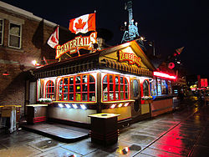
Company Name: Beaver Tails Pastry
Address: 315-9150 Meilleur Street, Montreal (QC), Canada, H2N 2A5
Locations: BeaverTails Pastry has stores all across Canada. A full list of the locations can be viewed on their directory at their website. (Beaver Tails Stores)
Owner: Pino Diloia (Beaver Tails FAQ)
Corporate Structure: Beaver Tails Pastry is a franchise, but other than that, there is little information regarding their corporate structure.
General Description of Product Lines:
“BeaverTails have been referred to as a Canadian culinary icon. These
deliciously addictive, traditional whole-wheat pastries are stretched by
hand to resemble the tail of a beaver, one of Canada’s best-known national
symbols. The pastries are then float cooked on high quality canola oil and
served piping hot, topped with butter and a choice of delectable flavours.”
(Beaver Tails Inc)
Export Experience: Besides Canada, Beaver Tails Pastry can also be found in Saudi Arabia and Breckenridge, Colorado (Beaver Tails FAQ). The franchise has also recently made its expansion into the United States (Montreal). On their website, the company notes that they are “always working on developing other great territories to expand [their] Canadian culinary icon.” Of course, the menu options for beaver tails in foreign countries vary slightly. This is largely due to adapt to the cultural preferences of the foreign nation (Beaver Tails FAQ).
Domestic Success: Beaver Tails Pastry is a huge success, both nationally and domestically. BeaverTails are an important staple in Canadian culture. In the past, there have been twenty six features of BeaverTails in internationally acclaimed press sources, such as Yahoo, Global News, the Huffington Post, and USA Today (Beaver Tails Media). Popularity of BeaverTails have skyrocketed since Obama was photographed with his own Beavertail (dubbed ObamaTail) in the Byward market. He also noted to his friends that he likes beavertails (Montreal).

PRODUCT
Essentially, Beavertails are sugared bread with custom toppings. Their name comes from the peculiar shape of the pastry, which resembles that of a beaver’s tail, Canada’s national animal. After being rolled into their famous shape, these pastries are fried and showered with a blend of sugar and cinnamon (Beaver Tails Patry).
There are many different types of toppings resulting in many different consumer choices. Clicking on the Products tab on the Beavertails website would lead users to the company’s Pinterest page, where pages of all the different types of beavertails and different shots of them are listed. Some of pictures these include the Choco Banane Beavertail, the Triple Trip and Coco Vanil’ BeaverTail, and the Works.
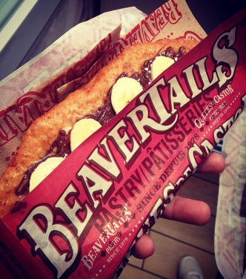
PRICE
Typically, the cost of a beavertail ranges between $3.25 to $5 CDN (Beaver Tails Pastry).
PROMOTION
The company does not do a lot of marketing to promote their products. They rely largely on their reputation as Canada’s staple pastry. However, the company still does some marketing. These other methods are generally done within their different franchises and include making posters, using Facebook, utilizing an in-house generated blog, their website, and word of mouth (Beaver Tails FAQ). By simply using these inexpensive means of advertising, BeaverTails Pastry has rapidly grown into the national success it is today.
PLACE
It isn’t only the franchise stores and stands that sell beavertails. Many companies also partner with BeaverTails Pastry to sell beavertails in their stores. Stores and stands are generally set up in high-traffic areas. For example, in the winter on the Rideau Canal, there is one BeaverTails Pastry stand every 2 or 3 km (Hines, Pama).

Japanese Culture: Fact Sheet
Acceptable and Unacceptable Topics of Conversation
- Your profession
- Prices or economic questions
- Person’s life
- Comparisons between your country and Japan
(Culture 4)
Main Language: The main language spoken in Japan is Japanese. For more information about languages spoken in Japan, please refer to section I of this report.
Business Language: “Virtually all business is conducted in English.” (eDiplomat)
However, English proficiency is very poor in Japan (Amid). Therefore, it would probably be ideal for foreign investors to learn Japanese.

Business Customs
Roles of Men, Women, and Children at Home
Roles in Japan revolve around a hierarchy where one’s age and position are greatly revered. This is evident in the depth of bow given to different members of society. In general, men are expected to be well rounded in the arts such as music and literature, just like in feudal Japan. The typical American “alpha male” is frowned upon. Parents are expected to be devoted to their workplace. Women are expected to look after children, but men are expected to know how to raise children and support the wife should she decide to work. . Children are expected to get good grades and be respectful. (Japan Powered)
Non-Verbal Communication
Japan is a high-context culture. This is evident in the language itself. For example, neko desu could mean it’s a cat, he is a cat, they are cats, my name is cat, etc.,
Because even the smallest of gestures could have significant meanings in such a high-context culture, it would be wise to avoid massive movements with the arms and unusual expressions (Kiss). Below are some additional tips:
- Keep direct eye contact to a minimum
- Avoid confrontation as much as possible so as not to disrupt the harmony or balance in their surrounding community
- Always remain calm
- Respect the sound of silence
- Read between the lines; “no” is rarely ever used
- Indirect approaches are best
- NEVER touch your conversation partner (Culture 4)
- Greet with a handshake. If they greet with a bow, observe carefully how deeply they bow and do the same. Bowing too deeply will put your partner in a position of power; bowing too slightly will humiliate them. Also note that eyes should be lowered and that men and women bow differently. 2. It is important to give gifts upon the first meeting, such as scotch. Note that the Japanese do not open gifts immediately upon receiving it. 3. Always wrap your gifts in Japan. This ensures that your packaging is of the highest quality and is not offensive. For example, black and white paper is unacceptable. 4. Tipping is not appropriate in Japan. 5. Men should wear formal business suits, never appearing casual. Women should dress conservatively and keep perfume, jewellery, and makeup to a minimum. Pants and high heels should be avoided. 6. If you wear a kimono in Japan, make sure you wear it left over right. Right-over-left is for corpses. (Kiss)
Business Negotiations
- As the Japanese prefer to avoid confrontation, a response such as “I’ll consider it,” or “maybe,” may actually mean “no.”
- Incorporate words like “I’m sorry,” into your vocabulary to be polite
- Using a Japanese lawyer instead of a western one is a good sign of a cooperative spirit
- The Japanese usually use the initially meeting to get to know you and ask to hear your proposal
- Contracts are not perceived as final agreements
- Show greatest respect to the oldest people (age equals rank).
- Do not be expected to be complimented on good work. This is because the group and not the individual is rewarded
- Do not make accusations or refuse anything directly; be indirect. also, do not ask questions that your conversation partner may be unable to answer
- On the job, the Japanese tend to be very serious and do not try to “lighten” things up with humor (Kiss).

International Marketing Plan
Importing BeaverTails Pastry’s beavertails should not be too difficult, but it does require special attention to several culture components. This section will detail what steps must be taken in order to integrate Beavertails into the Japanese market successfully. Although product, price, place, and promotion are all separate elements of the marketing mix, these components do overlap in some areas. It is for this reason that the following has not been broken up into subheadings.
Beavertails are a choice product for Japan to invest in. Unlike products such as ice cream, the success of beavertails does not depend on the climate. It also does not depend on geography, transportation, or the general infrastructure of Japan. The only setup beavertails requires is a stand and these are easily attainable. Also, beavertails are for consumers of all ages. Beavertails are like crepes; anyone can enjoy them. Plus, they do not interfere with any cultures or traditions
Beavertail in Japanese is ビーバーテール (biibaateeru). This may pose a problem due to the fact that the Japanese may think that the product being sold is an actual beavertail. This problem could be solved by shortening the syllables to ビバテル (Bibateru). If this is done, the connection to actual beavers will not be as obvious. Also, the name will be a lot shorter and snappier.
In Japan, it is considered feminine to like sweets. Many bakeries make pastries larger so that guys will feel masculine even though they have a sweet tooth (Excessive sweet toppings is also considered unmanly). (Japan Powered) The fact that beavertails are quite large and the fact that their topping portions are controllable make the ideal pastry for both men and women in Japan.
Because crepes are one of a kind, primary competition is nonexistent. Of course, there will always be secondary competition. This includes things like ice cream cones and crepe stands.
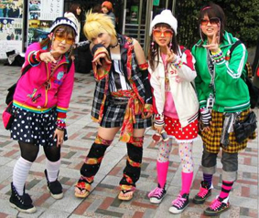
If beavertails were to be integrated into Japan, a choice location for the stand would be in the Harajuku district in Tokyo, Japan. This is ideal for several reasons.
Harajuku Girls
- Many tourists go to Tokyo. Beavertails would then not only be open to the Japanese, but also Canadians and other foreigners who are also in Japan at that time.
- Tokyo is about 30% more expensive than the rest of Japan, so having a high price would not seem unreasonable (should prices need to be raised in the future).
- The Harajuku district is famous for being the centre of Japanese youth culture and fashion. The focal point of this culture is on Takeshita Street and its side streets, which are lined by many trendy shops, fashion boutiques, crepe stands, and fast food outlets. These are geared towards the “fashion and trend conscious teens.” (Japan Guide) Given the whacky nature of beavertails, these pastries can definitely pick up speed and gain attention in this marketplace.
- In a way, beavertails are similar to crepes. Crepes are very popular in Japan; at the crepe stands in Harajuku, there is a long line almost every day. (YouTube)
Owning a BeaverTails Pastry franchise would not require a whole lot of set up. They are “not a super high-tech company” (BeaverTails FAQ) and they use videos to help train their franchisees.
Beavertails will be sold for 500 yen, which is roughly $5.00 Canadian. The price of beavertails isn’t even half of what minimum wage is in Japan ($11.00/hour), so beavertails would definitely be affordable to any working citizen (or citizen who has an allowance). Some factors to consider when setting this price is how much the ingredients will cost and the taxes. One will also have to pay tariffs. All of these factors have been considered upon setting this price of 500 yen.
As already outlined in previous sections, BeaverTails Pastry uses minimal advertising. Other than using Facebook and word of mouth, the company should create local posters. For best effect, beavertails should be written in katakana (one of the three Japanese alphabets) instead of hiragana. Japan has a literacy rate of nearly 99%, so many people will be able to read this. Also, foreigners who know a bit of Japanese will be able to read this poster and recognise what it’s saying (particularly if their main language is English) due to the nature of katakana and its close relationship to foreign words and simpler characters. Bright colours should also be used in the poster.
Most of the ingredients to make beavertails can be and should be purchased in Japan. This keeps the taste as authentic to Japanese culture as possible.

Recommendations and Conclusions

BeaverTails Pastry should definitely consider exporting its renowned beavertails to Japan. The company has already had international success both in the states and Saudi Arabia. This legacy of success should expand into the Asian market, more specifically Japan. To help make the integration into Japan successful, it is important to remember to modify the name from beavertails (ビーバーテール) to ビバテル. Also, it is important to make sure that most (if not all) of the ingredients are from Japan. This ensures a taste of Japan in the beavertails. One of the biggest tourist attractions is the Harajuku district in Tokyo and prices are 30% higher in Tokyo. This makes the Harajuku district a choice location for BeaverTails Pastry. It should also be noted that the beavertails should be wrapped in pretty paper. In Japan, presentation is everything (think about how much thought the Japanese put into wrapping gifts). A specialist would need to be hired for this job.

Currently, political and economic stability is great in Japan. Also, the Japanese government is encouraging foreign investment. Beavertails would not clash with customs or cultures in the country either. That being said, the beavertail’s delicious taste and uniqueness gives it a competitive advantage into any market it enters. Hopefully, this report has helped foreign investors make executive decisions in exporting the beavertail to Japan.

WORKS CITED
About: Asian History. 12 April. 2008. Web. 25 May 2014.
<http://asianhistory.about.com/od/governmentandlaw/a/JapaneseEmp.htm>
Amid East. 2 Nov. 2011. Web. 31 May 2014.
< http://www.amideast.org/blogs/toeic4success/2011/11/japans-english-language-problem-change-beginning>
Asahi Shimbun. 26 October. 2013. Web. 24 May 2014.
<http://ajw.asahi.com/article/behind_news/social_affairs/AJ201310260017>
BBC. 30 September. 2012. Web. 25 May. 2014.
<http://www.bbc.com/news/technology-19767970>
Beaver Tails Inc. 24 December. 2014. Web. 27 May 2014.
<http://www.beavertailsinc.com/wp_bt_2012/wp-content/uploads/2012/12/BT_PR-fact-sheet_EN_V3.pdf>
Beaver Tails Media. Web. 26 May 2014.
<http://www.beavertailsinc.com/media/in-the-press>
Beaver Tails: Pastry. 24 December. 2012. Web. 27 May 2014.
<http://www.beavertailsinc.com/wp_bt_2012/wp-content/uploads/2012/12/Lonely-Planet-Top-100-Street-Food.pdf>
Beaver Tails: Stores. 22 December. 2012. Web. 26 May 2014.
< http://www.beavertailsinc.com/stores>
Beaver Tails: FAQ. 24 December. 2012. Web. 26 May 2014.
< http://www.beavertailsinc.com/wp_bt_2012/wp-content/uploads/2012/12/BT_StudentFAQ_EN.pdf>
Business Anti-Corruption Portal. 18 March. 2013. Web. 24 May 2014.
<http://www.business-anti-corruption.com/country-profiles/east-asia-the-pacific/japan/snapshot.aspx>
CIA.1 Feb. 2011. Web. 25 Feb 2014.
<https://www.cia.gov/library/publications/the-world-factbook/fields/2103.html>

Cosmos. 29 March. 2013. Web. 11 Feb 2014.
<http://cosmos.phys.sci.ehime-u.ac.jp/meeting2013/guide.html>

Council on Foreign relations. 13 April 2006. Web. 24 May 2014.
<http://www.cfr.org/japan/japan-its-military/p10439>
Culture-4-Travel.17 Nov. 2013. Web. 31 May 2014.
< http://www.culture-4-travel.com/japanese-etiquette.html>

eDiplomat. 1 Feb. 2014. Web. 31 May 2014l
<http://www.ediplomat.com/np/cultural_etiquette/ce_ca.htm>

Ethnologue. 26 Feb. 2013. Web. 28 Feb 2014.
<http://www.ethnologue.com/country/JP/languages>

Free World Maps. 31 Jan. 2007. Web. 11 Feb 2014.
http://www.freeworldmaps.net/asia/japan/

Hines, Jacob. Loyal beavertails customer, Ottawa. Personal interview. Ottawa. 27 May. 2014.
Index Mundi. 26 Nov. 2003. Web. 11 Feb 2014.

Montreal About. 18 January. 2011. Web. 27 May 2014.
<http://montreal.about.com/od/foodwine/ss/beavertails-queues-de-castor-beaver-tail.htm>
Morrison, Terri et al. Kiss, Bow, or Shake Hands. Massachusetts:
Adams Media Corporation, 1994. Print.
Japan Auto Pages. 9 April. 2004. Web. 10 Feb 2014.
<http://www.japanautopages.com/useful_resources/ports.php>
Japan Customs. 1 April. 2014. Web. 24 May 2014.
<http://www.customs.go.jp/english/tariff/2014_4/data/e_39.htm>
Japan Guide. 26 May. 2011. Web. 11 Feb 2014.
<http://www.japan-guide.com/e/e2354.html>

Japan Times. 1 Jan. 2014. Web. 11 Feb 2014.
< http://www.japantimes.co.jp/news/2014/01/01/national/japans-population-falls-by-a-record-244000-in-2013/#.U0sgJPldV1Z>

Japan Travel. 1 Nov. 2008. Web. 11 Feb 2014.
<http://www.japantravel.com.au/Rail-Pass-Details.asp?RailPassID=39>

Jetro. 1 July. 2010. Web. 20 March 2014.
< http://www.jetro.go.jp/en/reports/statistics/>

Mecometer. 18 Jul. 2013. Web. 25 Feb 2014.
<http://mecometer.com/country/japan/demographics/>

Nation Master. 1 Feb. 2001. Web. 7 Feb 2014.
<http://www.nationmaster.com/graph/ide_cou_nam_con_lon_for-country-name-conventional-long-form>

OECD. 15 June. 2006. Web. 25 May 204.
<http://www.oecd.org/daf/anti-bribery/seriousconcernsremainoverjapansenforcementofforeignbriberylawdespitesomepositivedevelopments.htm>
Pama, Julia. Loyal beavertails customer, Ottawa. Personal interview. Ottawa. 27 May. 2014.
Prefecture Gifu. 2 Nov. 2007. Web.
< http://www.pref.gifu.lg.jp/pref/s11111/data/data.htm>

Rak, Brian. Human Japanese.
Brak Software, 2007. Digital.

Shultz, Mike et al. International Business: Canada and Global Trade. Toronto:
Nelson, 2003. Print.
Think Quest. 2010. Web. 10 Feb 2014.
<http://library.thinkquest.org/CR0211823/cities.htm,>

Tofugu. 25 April. 2014. Web. 25 April 2014.
<http://www.tofugu.com/2014/04/25/awful-japanese-black-companies/>
Total Okinawa. 22 April. 2011. Web. 10 Feb. 2014.
<http://www.totalokinawa.com/blog/2011/04/22/where-is-okinawa/>

Trading Economics. 21 Jul. 2010. Web. 25 Feb 2014.
<http://www.tradingeconomics.com/japan/rural-population-percent-of-total-population-wb-data.html>

Transparency International. 6 September. 2012. Web. 25 May 2014.
<http://blog.transparency.org/2012/09/06/bribery-is-bad-for-business/>
Washington Post. 9 Feb. 2014. Web. 24 May 2014.
< http://www.washingtonpost.com/world/shinzo-abes-comeback-as-prime-minister-drives-japans-turnaround/2014/02/08/38c6aaf4-8678-11e3-a760-a86415d0944d_story.html>
Wikipedia: 47th Japanese General Election. Web. 24 May 2014.
< http://en.wikipedia.org/wiki/47th_Japanese_general_election>
Wikipedia: Japanese Labour Law. Web. 25 May 2014.
<http://en.wikipedia.org/wiki/Japanese_labour_law>
World Bank. 21 April 2010. Web. 20 March 2014.
< http://data.worldbank.org/indicator/NY.GDP.PCAP.CD>

World Health Organization. 28 Feb. 2013. Web. 11 Feb 2014.
<http://apps.who.int/gho/data/node.main.688?lang=en>

World Politics Review. 26 June. 2013. Web. 24 May 2014.
< http://www.worldpoliticsreview.com/articles/13053/abe-brings-japan-political-stability-but-at-high-cost>
Zero Hedge. 5 December. 2013. Web. 24 May 2014.
<http://www.zerohedge.com/news/2012-12-05/usa-seen-more-corrupt-uk-japan-and-barbados>

