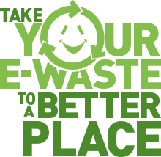
Pinterest Board about E-Waste

Assignment: Build a Pinterest Board called Impacts of E-waste.
Start Pinning! You can search on your Pinterest home page for these pictures. Remember you must change the caption and include your hashtags before it is Pinned to your Board.
These are the Pins you need:
- 5 Pins about what E-waste is. Change the caption to include the text “What it is”
- 5 Pins about what E-waste can be used for. Change the caption to include the text “The future of E-waste”
- 1 Pin that is an informational video about E-waste. Change the caption to include the text “Video about E-waste”
- 5 Pins about cool new electronics. Change the caption to include the text “Where will this go to die?”
- Review at least one peer’s Board and re-pin 3 of their Pins (they cannot already be on your board). Change the caption to “Re-pinned from Name”.
Self-Assessment
- Are there at least 19 Pins on your E-waste Board?
- Are your hashtags printed at least 5 times?
- Is there a video on your page that opens when you click it?
- Does your page easily explain what E-waste is?
- Does it clearly show the future of E-waste?
- Do you think it will inspire people to think twice about buying unnecessary new electronics?
- Do your re-pinned Pins make your Board better?

