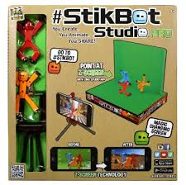
Stikbots Animation Assignment
Using the Stikbot animation studio, your task is to create a 15-20 second video, about some aspect of this course that you have learned.
- be creative, can be funny, keep it class appropriate
- you can use your own characters, toys, lego, action figures, props, etc.
- some ideas: ergonomics, computers & the environment, ethics, internet, social media, purchasing a computer, etc.

- You will have from December 14-December 21.
- **DUE BEFORE YOU LEAVE FOR CHRISTMAS BREAK
Category | 4 | 3 | 2 | 1
Video & Editing  /15 | Shots are well thought out and creative use of filming is evident. | Some shots are well thought out and some evidence of creativity. | Image choice is logical but not too creative. | Shots may be erratic, poorly composed, or confusing.
Soundtrack/Voice over  /5 | Sound matches the story line extremely well. | Sound somewhat matches the story line. | Sound is okay but it does not add much to the story. | Sound is distracting, inappropriate, or was not used.
Ergonomics  /10  Total /30 | Use of a movie making program was very effective to communicate an ergonomic situation. | Use of a movie making program was mostly effective to communicate an ergonomic situation. | Use of a movie making program was somewhat effective to communicate an ergonomic situation. | Use of a movie making program was not very effective to communicate an ergonomic situation.
- You will work with a group or 2 or 3 (max) and one person will need to download the Zing Stikbot Studio app (free).

Ergonomic Stikbot Video Planning Sheet
Ideas for Ergonomic Scene
__________________________________________________________________________________________________________________________________________________________________________________________________________________________________________________
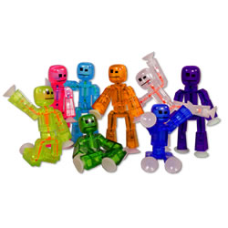
Characters:
__________________________________________________________________
Background:
__________________________________________________________________
Music:
____________________________________________
Voice:
____________________________________________

Scene Detail
__________________________________________________________________________________________________________________________________________________________________________________________________________________________________________________________________________________________________________________________________________________________________________________________________________________________________________
Idea we have chosen:
______________________________________________________________________________________________________________

