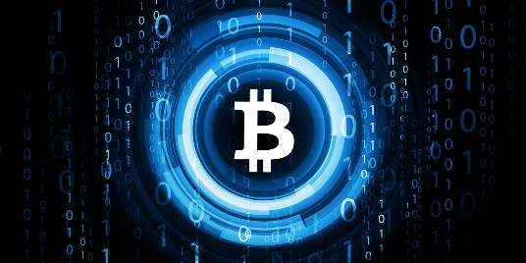
UNDERSTANDING CRYPTOCURRENCY
Use the link on the class website to answer the definitions and questions. https://getsmarteraboutcrypto.ca/
- Define:
Cryptoassets

Cryptocurrencies

Distributed ledger

Block chain

Private key

Miners

Digital tokens

Digital wallets

Cryptoasset kiosk

- How many Ontario adults own Cryptoassets as of March 2018?

- What are 2 examples of digital coins?

- What can Canadians use digital coins for?

- What is the most popular digital coin?

- How much money was raised by Canadian businesses in 2017 using digital tokens?

- Is a digital wallet secure? Why or why not?

- Where can you buy cryptoassets?

- Are trading platforms the same as regulated stock exchanges?

- Do cryptoassets have a bigger risk for theft from hackers than other investments?

- What 3 things are important to do before buying a digital token?
1-

2-

3-

- What do you need to earn cryptoassets through mining?

- Are cryptoassets the only way to break into a blockchain?

- If you are promised 100% interest in 100 days on your cryptoassets is that too good to be true?

- What are the 5 points to exercise caution before buying cryptoassets?
1-

2-

3-

4-

5-

